SimpleQ

Quiz Generator

DAAPS | Georgia Gwinnett College

Project Team

Palmer Simmons, Alvin Jean, Demetri Clark, Austin Seawell, Stuart Miller, Tracy Ediger, and Our Teacher Prof. Gunay

2016

Table of Contents

Features Implemented and Features Left Out 2

Known Issues 3

Description of Functionality 4

Team Members and Client Information 5

Testing Coverage, Methods, and Results 6

Usability Testing and Survey Results 7

User Documentation and Installation 8

License Agreement and Signatures 9

Creative Commons Attribution-NonCommercial-NoDerivatives 4.0 International Public License 9

# **Features Implemented and Features Left Out**

**Features Implemented**

* User being able to create account with Faculty Permissions
* User authentication (Login)
* Set permissions for Faculty (Creating quizzes)
* Consistent user session between pages (User login info preserved)
* Account Settings
  + Option to upload profile picture
    - Profile picture displays in settings
  + Displays Faculty ID, Email, and Username
  + Ability to change profile picture
  + Ability to change Password
  + Ability to change Email
* Logout Functionality
* Quiz Generator Functionality
* Create Generated Quiz
  + Template A Quiz: Multiple Pages, Multiple Pictures
  + Template B Quiz: One Page, Multiple Pictures
  + Template C Quiz: One Page, One Picture
  + Ability to choose number of questions per quiz
* Under Make Quiz, Ability to view results from quiz created by current Faculty user
* Quiz List showing all of the quizzes made by authorize faculty users.
* Search Quiz functionality, can search for quizzes by name\
* User Documentation page to help the Faculty user know how to create and display quizzes.

Features Left Out

* Edit quiz functionality not implemented

# **Known Issues**

**Edit Quiz**

Editing the Quiz does not properly allow the user to edit, with how the code is written the PHP/HTML code is improperly formatted when it writes itself and produces a whole heap of errors.

**Picture Sizing**

Pictures are not properly formatted either, the sizing is off and they sometimes do not display properly.

# **Description of Functionality**

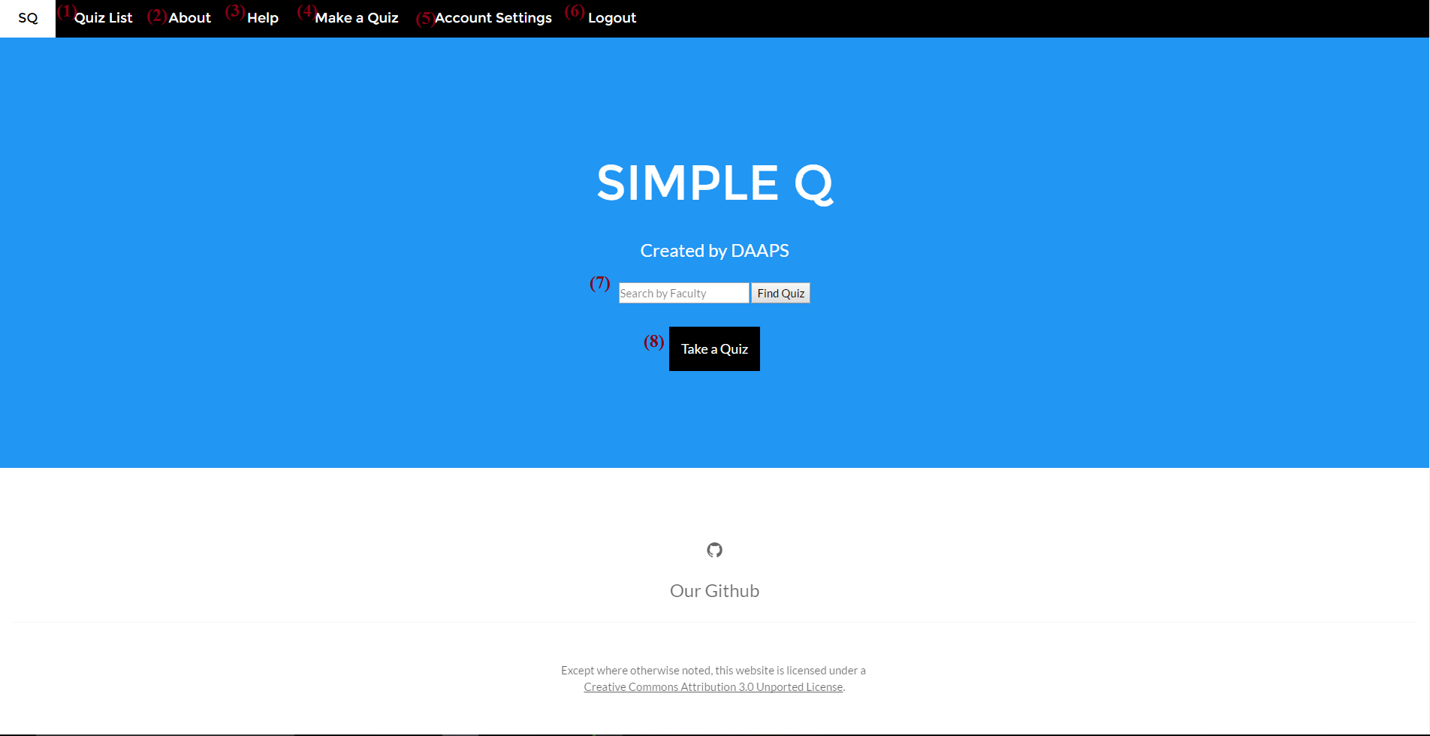

1. Quiz List: Displays the current listing of the Quizzes, pulls information from the database to display on the page
2. About Page: Displays Information about the project and the team
3. User Documentation: Displays the step by step guide on how to work the quiz generator
4. Make a Quiz: When logged in, it prompts the Quiz Generator functionality
5. Account Settings: Allows a logged-in user to change their account settings and review any key information
6. Logout button: logout of user and sends them back to the initial page
7. Search Function: allows user to search for a quiz by name specifically
8. Take a Quiz: sends a user straight to the quiz list.

# **Team Members and Client Information**

**Alvin Jean:**

Project Manager & Data Modeler

Soft Dev Major

Senior at GGC

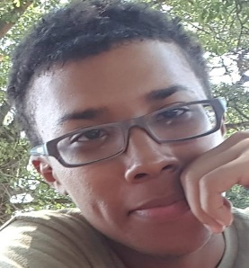Loves Music & Coding

**Palmer Simmons:**

Lead Documentation & Data Assist

Soft Dev Major

Senior at GGC

Loves Gaming & Coding

**Austin Seawell:**

Lead Developer & UI Assist

Soft Dev Major

Current student at GGC

Likes dank memes & Coding

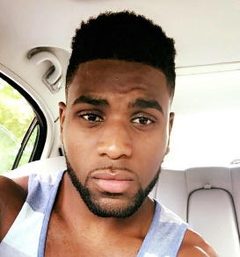**Demetri Clark:**

UI Lead & Client Liasion

Soft Dev Major

Graduate of 2016!

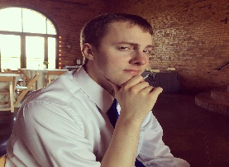Enjoys Coding

**Stuart Miller:**

Testing Lead & Develop Assist

Soft Dev Major

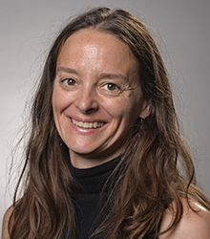Current student at GGC

**Tracy Ediger:**

Client for SimpleQ

Assistant Professor of Biology

Likes hiking, baking, arts & crafts

# **Testing Coverage, Methods, and Results**

Tests were run to test the interactions between the database and the system, the main methods testing the ability to find by id, successful table creation, and successfully populating a table.

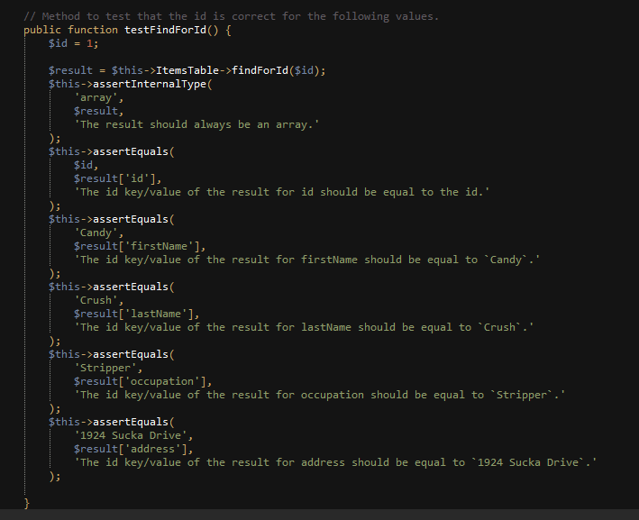

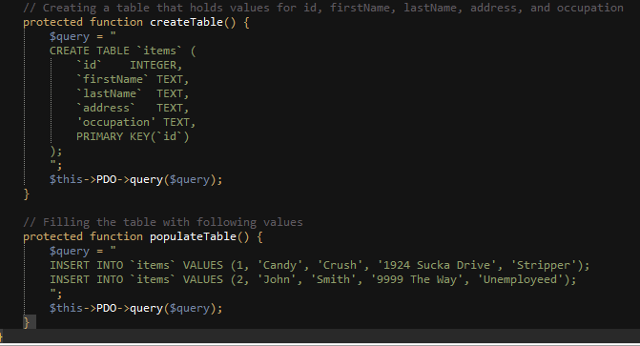

Here are some of our test results for the above tests.

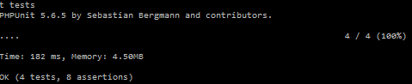

# **Usability Testing and Survey Results**

Before the CREATE symposium, the team decided to make a second-to-last product which implemented most of the features. This product was given to the client to administer a mock up quiz to her students and the students were provided with a survey at the very end.

Here are some of the student’s suggestions to the product:

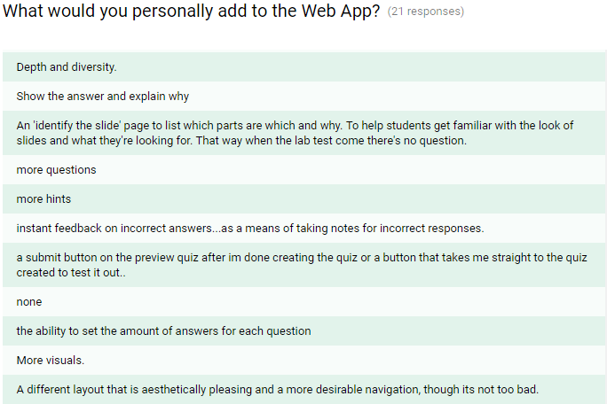

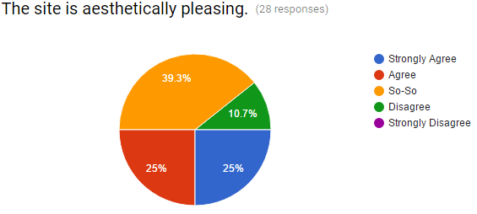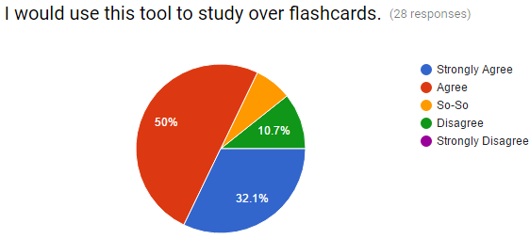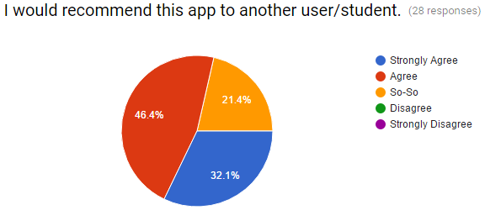With the suggestions, we implemented a better styling of the page and the ability for each user to receive metrics at the end of the quiz the had just taken. Overall, we refined the product with some of these suggestions and we received pretty positive feedback at the CREATE symposium!

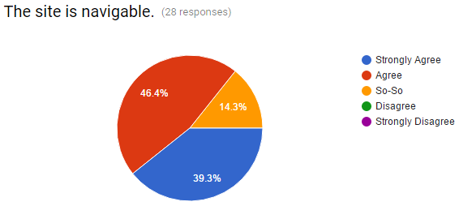

Overall our product received positive remarks during CREATE with a small percentage of users who are still not convinced of using the site over other study tools. As well as a small percentage of users who were not pleased with the aesthetics of the site.

# **User Documentation and Installation**

User help Documentation is provided on our website. If users need help they can click the “Help” tab located on the navigation bar of the page.



Developer Installation is provided in the readme file on our github repo which lays out how a developer can set up their environment in a way that they can effectively work on and edit the software system.

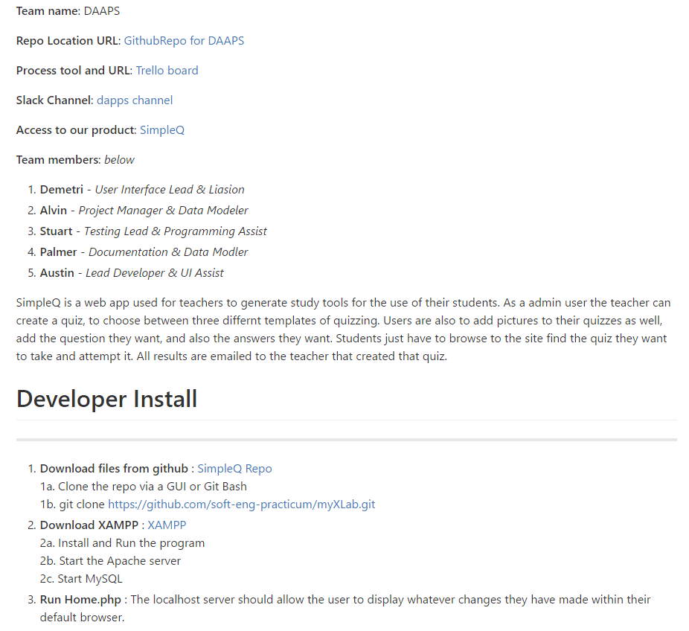

# **License Agreement and Signatures**

Human-Readable Summary of the license [here](https://creativecommons.org/licenses/by-nc-nd/4.0/).

### Creative Commons Attribution-NonCommercial-NoDerivatives 4.0 International Public License

By exercising the Licensed Rights (defined below), You accept and agree to be bound by the terms and conditions of this Creative Commons Attribution-NonCommercial-NoDerivatives 4.0 International Public License ("Public License"). To the extent this Public License may be interpreted as a contract, You are granted the Licensed Rights in consideration of Your acceptance of these terms and conditions, and the Licensor grants You such rights in consideration of benefits the Licensor receives from making the Licensed Material available under these terms and conditions.

**Section 1 – Definitions.**

1. **Adapted Material** means material subject to Copyright and Similar Rights that is derived from or based upon the Licensed Material and in which the Licensed Material is translated, altered, arranged, transformed, or otherwise modified in a manner requiring permission under the Copyright and Similar Rights held by the Licensor. For purposes of this Public License, where the Licensed Material is a musical work, performance, or sound recording, Adapted Material is always produced where the Licensed Material is synched in timed relation with a moving image.
2. **Copyright and Similar Rights** means copyright and/or similar rights closely related to copyright including, without limitation, performance, broadcast, sound recording, and Sui Generis Database Rights, without regard to how the rights are labeled or categorized. For purposes of this Public License, the rights specified in Section [2(b)(1)-(2)](https://creativecommons.org/licenses/by-nc-nd/4.0/legalcode#s2b) are not Copyright and Similar Rights.
3. **Effective Technological Measures** means those measures that, in the absence of proper authority, may not be circumvented under laws fulfilling obligations under Article 11 of the WIPO Copyright Treaty adopted on December 20, 1996, and/or similar international agreements.
4. **Exceptions and Limitations** means fair use, fair dealing, and/or any other exception or limitation to Copyright and Similar Rights that applies to Your use of the Licensed Material.
5. **Licensed Material** means the artistic or literary work, database, or other material to which the Licensor applied this Public License.
6. **Licensed Rights** means the rights granted to You subject to the terms and conditions of this Public License, which are limited to all Copyright and Similar Rights that apply to Your use of the Licensed Material and that the Licensor has authority to license.
7. **Licensor** means the individual(s) or entity(ies) granting rights under this Public License.
8. **NonCommercial** means not primarily intended for or directed towards commercial advantage or monetary compensation. For purposes of this Public License, the exchange of the Licensed Material for other material subject to Copyright and Similar Rights by digital file-sharing or similar means is NonCommercial provided there is no payment of monetary compensation in connection with the exchange.
9. **Share** means to provide material to the public by any means or process that requires permission under the Licensed Rights, such as reproduction, public display, public performance, distribution, dissemination, communication, or importation, and to make material available to the public including in ways that members of the public may access the material from a place and at a time individually chosen by them.
10. **Sui Generis Database Rights** means rights other than copyright resulting from Directive 96/9/EC of the European Parliament and of the Council of 11 March 1996 on the legal protection of databases, as amended and/or succeeded, as well as other essentially equivalent rights anywhere in the world.
11. **You** means the individual or entity exercising the Licensed Rights under this Public License. **Your** has a corresponding meaning.

**Section 2 – Scope.**

1. **License grant**.
   1. Subject to the terms and conditions of this Public License, the Licensor hereby grants You a worldwide, royalty-free, non-sublicensable, non-exclusive, irrevocable license to exercise the Licensed Rights in the Licensed Material to:
      1. reproduce and Share the Licensed Material, in whole or in part, for NonCommercial purposes only; and
      2. produce and reproduce, but not Share, Adapted Material for NonCommercial purposes only.
   2. Exceptions and Limitations. For the avoidance of doubt, where Exceptions and Limitations apply to Your use, this Public License does not apply, and You do not need to comply with its terms and conditions.
   3. Term. The term of this Public License is specified in Section [6(a)](https://creativecommons.org/licenses/by-nc-nd/4.0/legalcode#s6a).
   4. Media and formats; technical modifications allowed. The Licensor authorizes You to exercise the Licensed Rights in all media and formats whether now known or hereafter created, and to make technical modifications necessary to do so. The Licensor waives and/or agrees not to assert any right or authority to forbid You from making technical modifications necessary to exercise the Licensed Rights, including technical modifications necessary to circumvent Effective Technological Measures. For purposes of this Public License, simply making modifications authorized by this Section [2(a)(4)](https://creativecommons.org/licenses/by-nc-nd/4.0/legalcode#s2a4) never produces Adapted Material.
   5. Downstream recipients.
      1. Offer from the Licensor – Licensed Material. Every recipient of the Licensed Material automatically receives an offer from the Licensor to exercise the Licensed Rights under the terms and conditions of this Public License.
      2. No downstream restrictions. You may not offer or impose any additional or different terms or conditions on, or apply any Effective Technological Measures to, the Licensed Material if doing so restricts exercise of the Licensed Rights by any recipient of the Licensed Material.
   6. No endorsement. Nothing in this Public License constitutes or may be construed as permission to assert or imply that You are, or that Your use of the Licensed Material is, connected with, or sponsored, endorsed, or granted official status by, the Licensor or others designated to receive attribution as provided in Section [3(a)(1)(A)(i)](https://creativecommons.org/licenses/by-nc-nd/4.0/legalcode#s3a1Ai).
2. **Other rights**.
   1. Moral rights, such as the right of integrity, are not licensed under this Public License, nor are publicity, privacy, and/or other similar personality rights; however, to the extent possible, the Licensor waives and/or agrees not to assert any such rights held by the Licensor to the limited extent necessary to allow You to exercise the Licensed Rights, but not otherwise.
   2. Patent and trademark rights are not licensed under this Public License.
   3. To the extent possible, the Licensor waives any right to collect royalties from You for the exercise of the Licensed Rights, whether directly or through a collecting society under any voluntary or waivable statutory or compulsory licensing scheme. In all other cases the Licensor expressly reserves any right to collect such royalties, including when the Licensed Material is used other than for NonCommercial purposes.

**Section 3 – License Conditions.**

Your exercise of the Licensed Rights is expressly made subject to the following conditions.

1. **Attribution**.
   1. If You Share the Licensed Material, You must:
      1. retain the following if it is supplied by the Licensor with the Licensed Material:
         1. identification of the creator(s) of the Licensed Material and any others designated to receive attribution, in any reasonable manner requested by the Licensor (including by pseudonym if designated);
         2. a copyright notice;
         3. a notice that refers to this Public License;
         4. a notice that refers to the disclaimer of warranties;
         5. a URI or hyperlink to the Licensed Material to the extent reasonably practicable;
      2. indicate if You modified the Licensed Material and retain an indication of any previous modifications; and
      3. indicate the Licensed Material is licensed under this Public License, and include the text of, or the URI or hyperlink to, this Public License.

For the avoidance of doubt, You do not have permission under this Public License to Share Adapted Material.

* 1. You may satisfy the conditions in Section [3(a)(1)](https://creativecommons.org/licenses/by-nc-nd/4.0/legalcode#s3a1) in any reasonable manner based on the medium, means, and context in which You Share the Licensed Material. For example, it may be reasonable to satisfy the conditions by providing a URI or hyperlink to a resource that includes the required information.
  2. If requested by the Licensor, You must remove any of the information required by Section [3(a)(1)(A)](https://creativecommons.org/licenses/by-nc-nd/4.0/legalcode#s3a1A) to the extent reasonably practicable.

**Section 4 – Sui Generis Database Rights.**

Where the Licensed Rights include Sui Generis Database Rights that apply to Your use of the Licensed Material:

1. for the avoidance of doubt, Section [2(a)(1)](https://creativecommons.org/licenses/by-nc-nd/4.0/legalcode#s2a1) grants You the right to extract, reuse, reproduce, and Share all or a substantial portion of the contents of the database for NonCommercial purposes only and provided You do not Share Adapted Material;
2. if You include all or a substantial portion of the database contents in a database in which You have Sui Generis Database Rights, then the database in which You have Sui Generis Database Rights (but not its individual contents) is Adapted Material; and
3. You must comply with the conditions in Section [3(a)](https://creativecommons.org/licenses/by-nc-nd/4.0/legalcode#s3a) if You Share all or a substantial portion of the contents of the database.

For the avoidance of doubt, this Section [4](https://creativecommons.org/licenses/by-nc-nd/4.0/legalcode#s4) supplements and does not replace Your obligations under this Public License where the Licensed Rights include other Copyright and Similar Rights.

**Section 5 – Disclaimer of Warranties and Limitation of Liability.**

1. **Unless otherwise separately undertaken by the Licensor, to the extent possible, the Licensor offers the Licensed Material as-is and as-available, and makes no representations or warranties of any kind concerning the Licensed Material, whether express, implied, statutory, or other. This includes, without limitation, warranties of title, merchantability, fitness for a particular purpose, non-infringement, absence of latent or other defects, accuracy, or the presence or absence of errors, whether or not known or discoverable. Where disclaimers of warranties are not allowed in full or in part, this disclaimer may not apply to You.**
2. **To the extent possible, in no event will the Licensor be liable to You on any legal theory (including, without limitation, negligence) or otherwise for any direct, special, indirect, incidental, consequential, punitive, exemplary, or other losses, costs, expenses, or damages arising out of this Public License or use of the Licensed Material, even if the Licensor has been advised of the possibility of such losses, costs, expenses, or damages. Where a limitation of liability is not allowed in full or in part, this limitation may not apply to You.**
3. The disclaimer of warranties and limitation of liability provided above shall be interpreted in a manner that, to the extent possible, most closely approximates an absolute disclaimer and waiver of all liability.

**Section 6 – Term and Termination.**

1. This Public License applies for the term of the Copyright and Similar Rights licensed here. However, if You fail to comply with this Public License, then Your rights under this Public License terminate automatically.
2. Where Your right to use the Licensed Material has terminated under Section [6(a)](https://creativecommons.org/licenses/by-nc-nd/4.0/legalcode#s6a), it reinstates:
   1. automatically as of the date the violation is cured, provided it is cured within 30 days of Your discovery of the violation; or
   2. upon express reinstatement by the Licensor.

For the avoidance of doubt, this Section [6(b)](https://creativecommons.org/licenses/by-nc-nd/4.0/legalcode#s6b) does not affect any right the Licensor may have to seek remedies for Your violations of this Public License.

1. For the avoidance of doubt, the Licensor may also offer the Licensed Material under separate terms or conditions or stop distributing the Licensed Material at any time; however, doing so will not terminate this Public License.
2. Sections [1](https://creativecommons.org/licenses/by-nc-nd/4.0/legalcode#s1), [5](https://creativecommons.org/licenses/by-nc-nd/4.0/legalcode#s5), [6](https://creativecommons.org/licenses/by-nc-nd/4.0/legalcode#s6), [7](https://creativecommons.org/licenses/by-nc-nd/4.0/legalcode#s7), and [8](https://creativecommons.org/licenses/by-nc-nd/4.0/legalcode#s8) survive termination of this Public License.

**Section 7 – Other Terms and Conditions.**

1. The Licensor shall not be bound by any additional or different terms or conditions communicated by You unless expressly agreed.
2. Any arrangements, understandings, or agreements regarding the Licensed Material not stated herein are separate from and independent of the terms and conditions of this Public License.

**Section 8 – Interpretation.**

1. For the avoidance of doubt, this Public License does not, and shall not be interpreted to, reduce, limit, restrict, or impose conditions on any use of the Licensed Material that could lawfully be made without permission under this Public License.
2. To the extent possible, if any provision of this Public License is deemed unenforceable, it shall be automatically reformed to the minimum extent necessary to make it enforceable. If the provision cannot be reformed, it shall be severed from this Public License without affecting the enforceability of the remaining terms and conditions.
3. No term or condition of this Public License will be waived and no failure to comply consented to unless expressly agreed to by the Licensor.
4. Nothing in this Public License constitutes or may be interpreted as a limitation upon, or waiver of, any privileges and immunities that apply to the Licensor or You, including from the legal processes of any jurisdiction or authority.

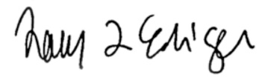 12/8/2016

**__________________________________ __________**

Tracy Ediger Date

Assistant Professor of Biology; Client



